#### Goal:

Our goal was to establish a computational workflow for Specialized to relate metabolic energy expenditure rate (MEER) and bicycle saddle position (R, 𝜽) to inform bicycle design.

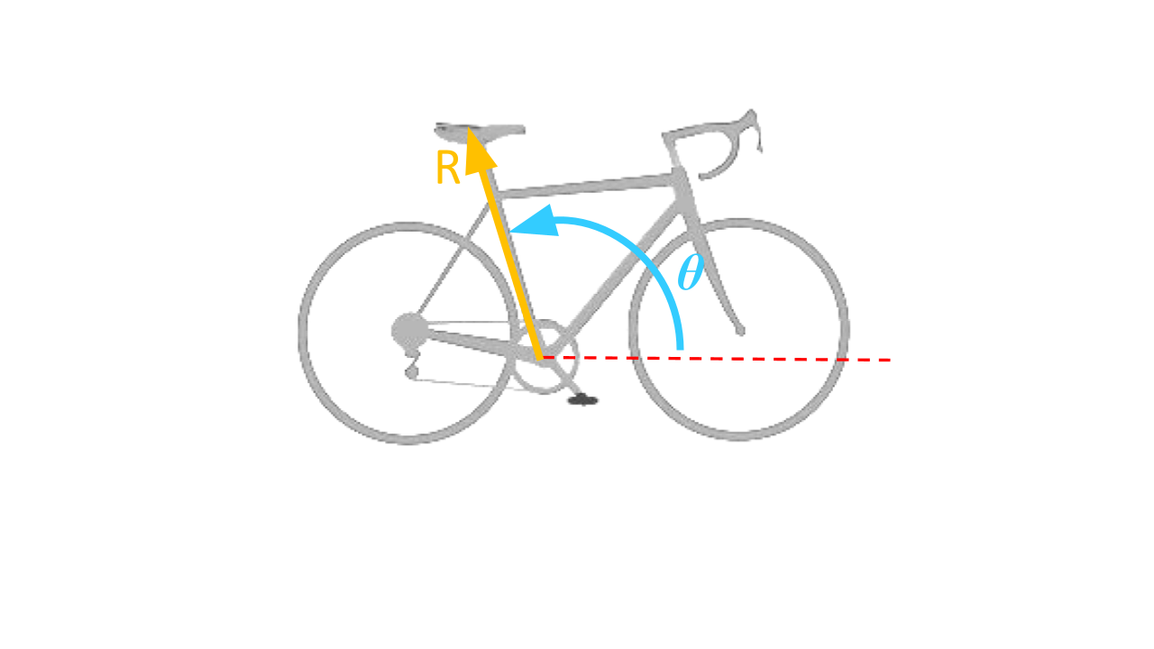

#### Problem:

A bike is considered to be one of the most efficient modes of transportation. Personalizing the design and fit of a bike for a rider is one of the methods to make cycling even more efficient for elite cyclists. Traditional subject-specific methods are time-intensive and costly and typically use experimental 3D motion capture, EMG, and indirect calorimetry. Biomechanics modeling tools, such as OpenSim, have been used to model human interaction in various environments and can be applied to cycling to help understand how changes in saddle position affect efficiency. The team was tasked with understanding the current computational capabilities of OpenSim in order to develop a validated workflow to relate how saddle position affects metabolic energy expenditure rate (MEER).

#### What did the team do?

Overall, we developed a computational workflow to relate cyclist MEER to saddle position. Using the workflow, we generated and analyzed results to show confirmation that the workflow could be implemented on a musculoskeletal model we created in OpenSim. We used this workflow for a set of six saddle positions and analyzed the results through a two-step process using Forward Dynamics and Computed Muscle Control (CMC) OpenSim Tool solvers. With an input of saddle position, the workflow used OpenSim modeling to establish the relationship between changes in saddle position and MEER. The results showed a clear indication of which saddle position had the lowest total full-cycle averaged MEER. MEER was also analyzed for each muscle, allowing for a deeper understanding of the total MEER for each saddle position. Furthermore, biomechanics muscle states analysis for active force capacity proved useful for our workflow objectives, both as a validation step for the MEER analysis and as a standalone analysis method.

**Please use this Google Drawing file as the main image for the workflow on the website**[**https://docs.google.com/drawings/d/1ZcekwVIo0FQNkHftU-2aqs-KSgMyn8DzmXjMXaD7oa8/edit?usp=sharing**](https://docs.google.com/drawings/d/1ZcekwVIo0FQNkHftU-2aqs-KSgMyn8DzmXjMXaD7oa8/edit?usp=sharing)

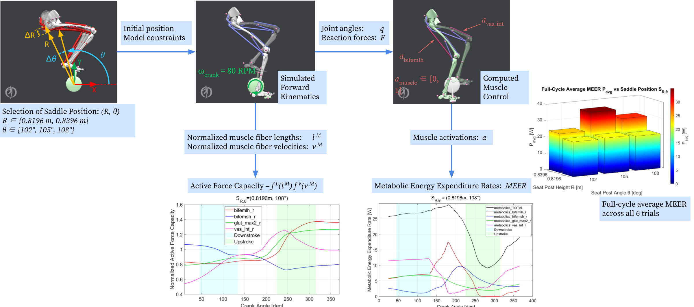

**Extra figures for reference:**

